Housing (Wales) Act 2014

Landlord Online Training Course

This resource is to enable you to create notes to use as a reference tool while you are working through Online Training Course Modules.
Each page highlights a module topic and the main points covered.
Write on the document by clicking on the grey text box found on each page under the headings and start typing.
Save or Print to use at your convenience.
You many find this a useful aid during the Online Assessment and for your reference.

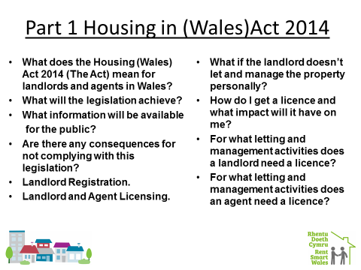

Type Here:

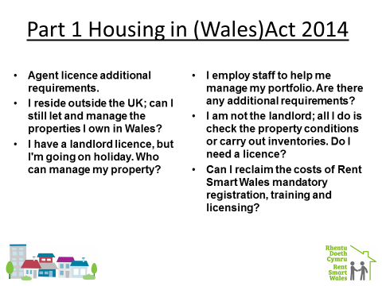

Type Here:

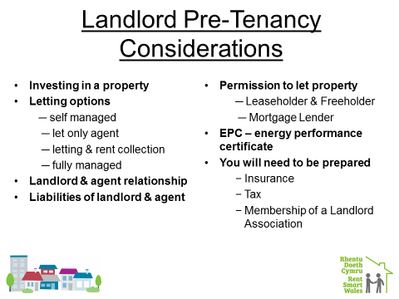

Type Here:

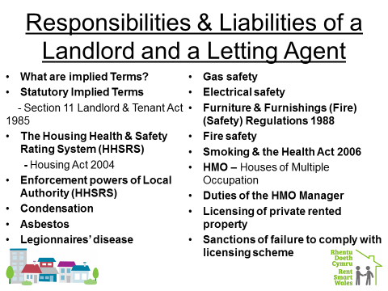

Type Here:

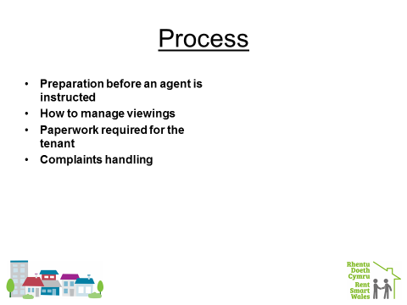

Type Here:

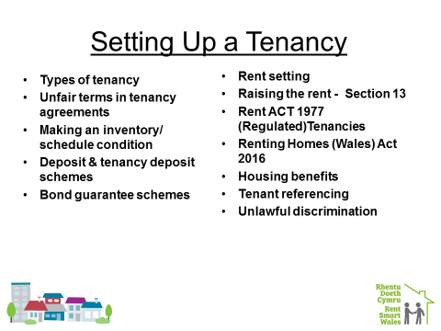

Type Here:

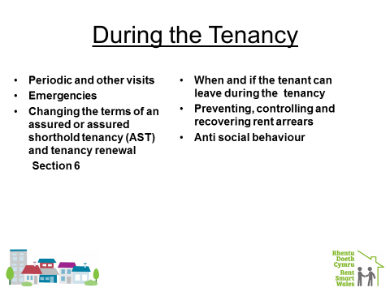

Type Here:

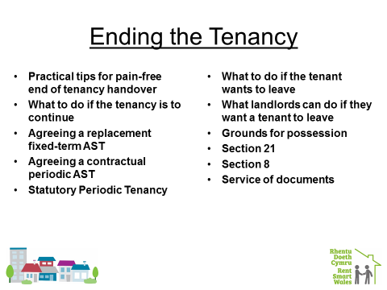

Type Here:

